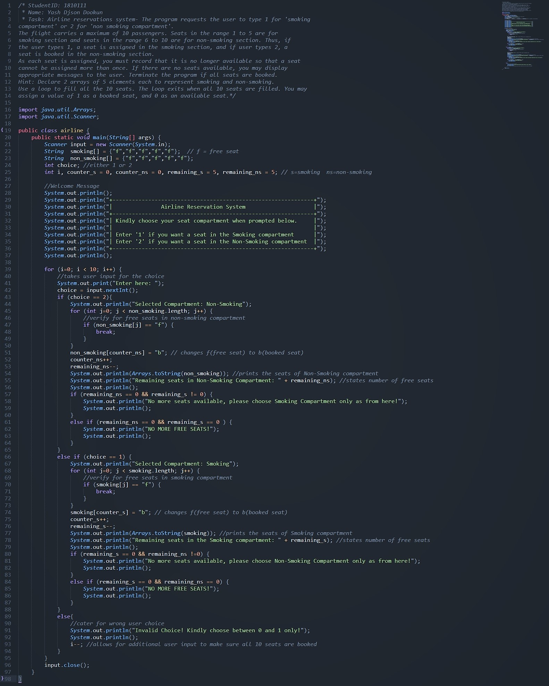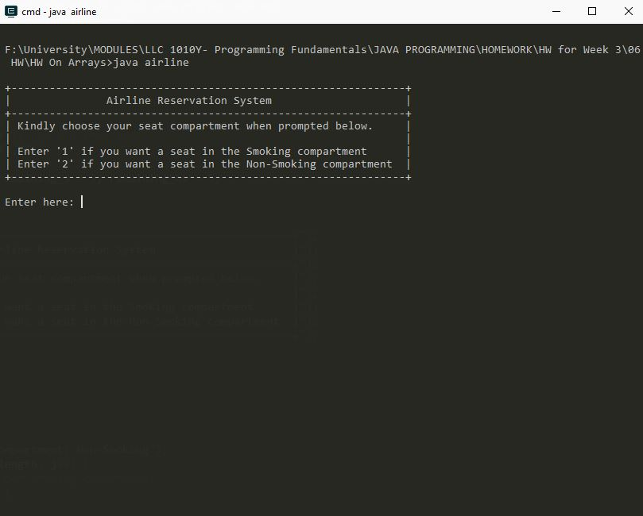

* The Welcome Screen when the Program is executed
* The user inputs his choice (1/2) when prompted

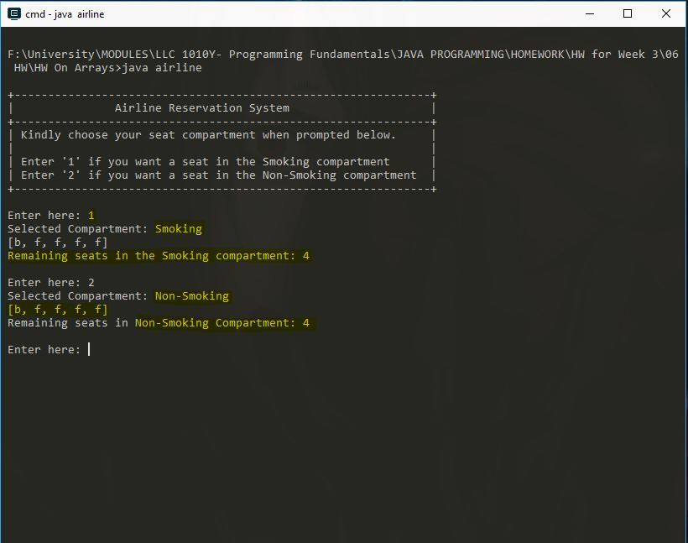

* Free seats are represented by ‘f’
* Booked seats are represented by ‘b’
* By default, all the seats (in both compartments) are marked as free seats (i.e, f)
* When a user chooses a compartment, a ‘free’ seat is updated to ‘booked’
* The current booked and free seats are printed
* And the number of remaining free seats is shown

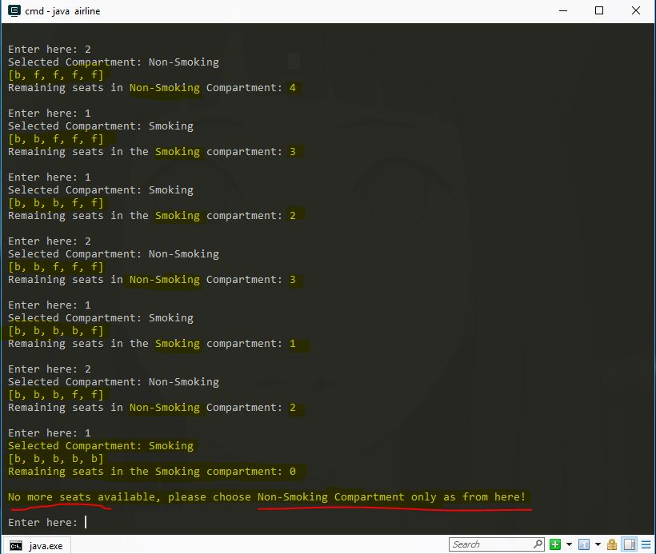

* As the user inputs choices, the updated array of seats is displayed and the number of free seats is shown
* If the **Smoking** Compartment is fully booked, the program checks if the are free seats in the **non-smoking** Compartment
* If yes, the user is prompted to only choose *Non-Smoking* as from here on

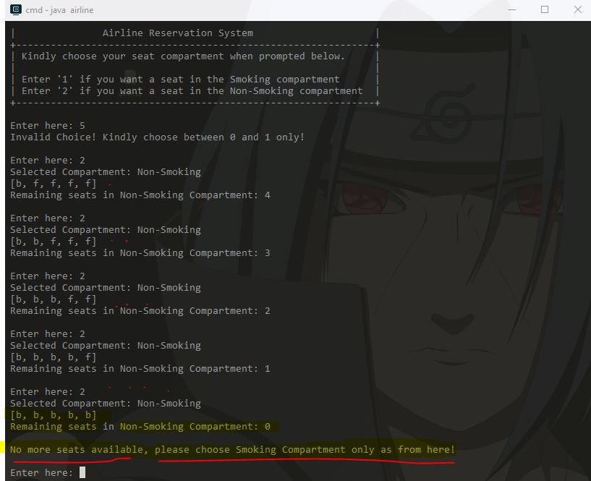

* Same goes for the opposite; should the **Non-Smoking** compartment be fully booked, the program checks for free seats in the **Smoking** compartment and asks the user to book there!

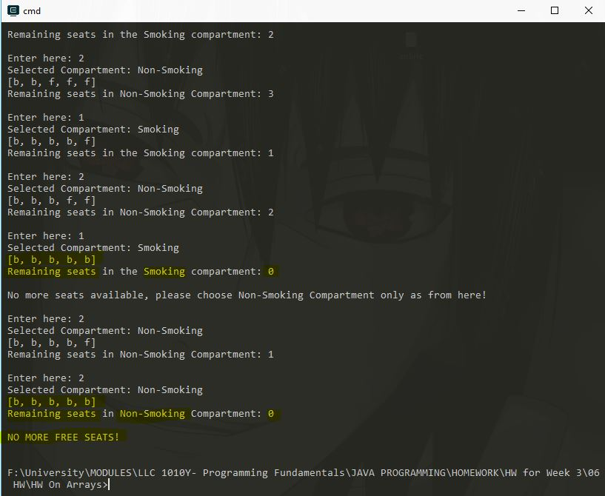

* If the program reaches the point where all the 10 slots have been booked (5 in Smoking + 5 in Non-Smoking), the Program gets terminated with a “No more free seats!” message!
* The program cross checked in both compartments first before reaching to the conclusion that there are indeed no seats available.

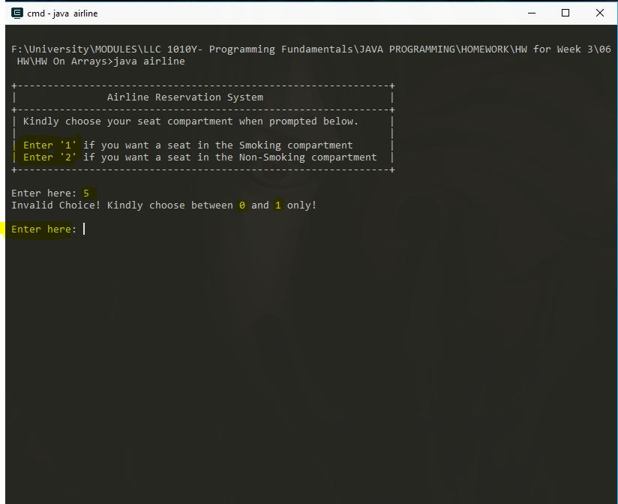

* If the user enters a value other than 1 or 2, the program will inform him/her and prompt him/her to retry.
* The program will iterate the User input step as long as the user doesn’t input 1 or 2 or until all the 10 seats are not booked.